GE4142
4 in 1 Multimedia Player, with Magnetic Cartridge

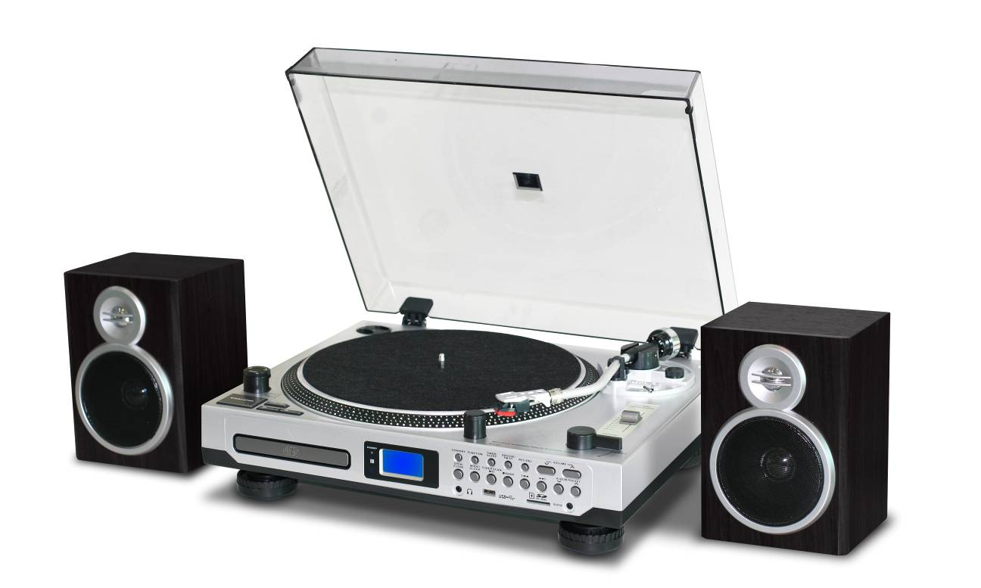

INSTRUCTION MANUAL

READ THIS INSTRUCTION MANUAL CAREFULLY BEFORE USE

PRODUCT FEATURES
- 33/45 RPM SELECTABLE TURNTABLE
- BELT DRIVEN SYSTEM
- PRORAMMABLE CD/MP3 PLAYER
- DIRECT USB/SD ENCODING FOR CD, TURNTABLE, FM RADIO & AUX IN
- AUX IN FOR CONNECTION OF OTHER DEVICE (EG. CD & MP3 PLAYER)
- USB/SD SLOT FOR MP3 PLAYBACK
- PLL RADIO WITH PRESET 20 AM & 30 FM STATIONS
- CLOCK / SLEEP / TIMER FUNCTION
- LCD DISPLAY WITH BLUE BACKLIGHT
- RCA LINE-OUT
- EXTERNAL 2 X 4W SPEAKER BOX
- 45RPM ADAPTOR & REMOTE CONTROL
- +/- 10% PITCH CONTROL
- ACCESSORIES INCLUDED:
- TURNTABLE PLATTER
- TURNTABLE SILICON MAT
- DUST COVER
- 45 RPM ADAPTOR
- COUNTERWEIGHT
- HEADSHELL
- AUDIO TECHNICA CARTRIDGE
- REMOTE CONTROL
- OPERATION MANUAL

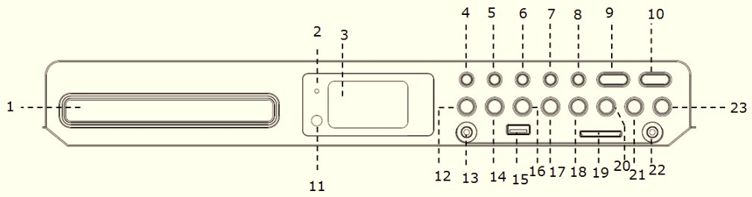

LOCATION OF CONTROL

- CD DOOR
- STANDBY INDICATOR
- LCD DISPLAY
- STANDBY
- FUNCTION
- TIMER/SLEEP
- SNOOZE/FM ST.
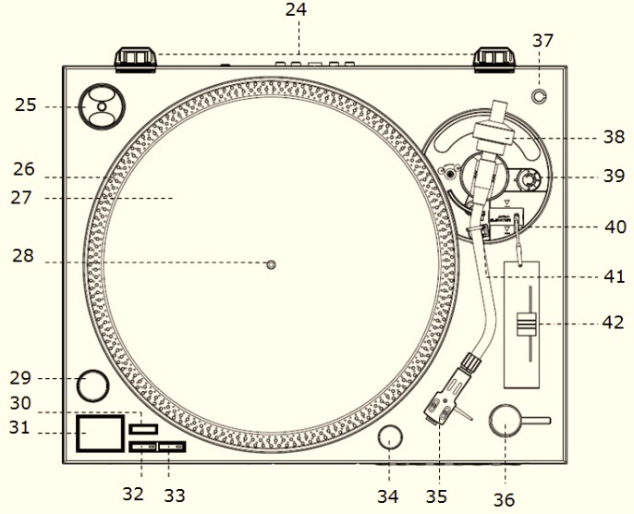
- REC / DEL
- VOLUME DOWN
- VOLUME UP
- REMOTE CONTROL RECEIVER
- CD OPEN / CLOSE
- EARPHONE JACK
- MODE / CLOCK
- USB SOCKET
- TUNER SCAN / PLAY/PAUSE
- STOP / BAND BUTTON
- SKIP DOWN
- SD/MMC CARD SLOT
- SKIP UP
- ALBUM / PRESET DOWN
- AUX IN JACK
- ALBUM / PRESET UP
- HINGE FOR DUST COVER
- 45 RPM ADAPTOR
- STROBE DOTS
- SLIP MAT
- CENTER SPINDLE
- POWER SWITCH / STROBE
- TARGET LIGHT SWTICH
- START / STOP BUTTON
- 33RPM SPEED SELECT BUTTON
- 45RPM SPEED SELECT BUTTON
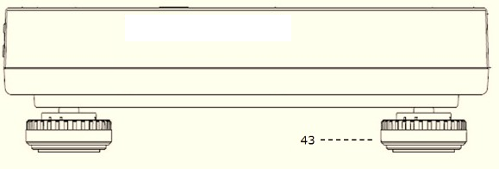
- TARGET LIGHT
- HEADSHELL
- EJECT
- POSITION FOR PREPARING CARTRIDGE
- COUNTERWEIGHT
- ANTI-SKATE KNOB
- LIFT LEVER
- TONE ARM REST PART
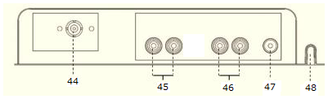
- PITCH CONTROL SLIDER (+/- 10%)
- TURNTABLE FOOT
- FM WIRE ANTENNA
- SPEAKER SOCKET
- LINE-OUT SOCKET
- GROUND TERMINAL
- AC POWER CORD

CAUTION:
USAGE OF CONTROLS OR ADJUSTMENTS OR PERFORMANCE OF PROCEDURES OTHER THAN THOSE SPECIFIED HEREIN MAY RESULTE IN HAZARDOUS RADIATION EXPOSURE.
THIS UNIT SHOULD NOT BE ADJUSTED OR REPAIRED BY ANYONE EXCEPT QUALIFIED SERVICE PERSONNEL.

WARNING:
- THE APPARATUS SHALL NOT BE EXPOSED TO DRIPPING OR SPLASHING AND THAT NO OBJECTS FILLED WITH LIQUIDS, SUCH AS VASES, SHALL BE PLACED ON THE APPARATUS.
- BATTERIES (BATTERY PACK OR BATTERIES INSTALLED) SHALL NOT BE EXPOSED TO EXCESSIVE HEAT SUCH AS SUNSHINE, FIRE OR THE LIKE.
- THE MAINS PLUGS OR AN APPLIANCE COUPLER IS USED AS THE DISCONNECT DEVICE, AND THE DISCONNECT DEVISE SHALL REMAIN READILY OPERABLE.

PRECAUTIONS FOR USE

INSTALLATION
- UNPACK ALL PARTS AND REMOVE PROTECTIVE MATERIAL.
- DO NOT CONNECT THE UNIT TO THE MAINS BEFORE CHECKING THE MAINS VOLTAGE AND BEFORE ALL OTHER CONNECTIONS HAVE BEEN MADE.
- DO NOT COVER ANY VENTS AND MAKE SURE THAT THERE IS A SPACE OF SEVERAL CENTIMETERS AROUND THE UNIT FOR VENTILATION.

CONNECTION
- PLUG THE UNIT INTO A SUITABLE MAINS SOCKET
- CONNECT SPEAKER BOX WITH SPEAKER SOCKET
- TURN THE POWER SWTICH CLOCKWISE TO ENTER TO STANDBY MODE, STANDBY INDICATOR WILL BE ON. THE STROBE ILLUMINATOR WHICH IS LOCATED BENEATH THE SWTICH WILL LIGHT UP.
- PUSH THE STANDBY BUTTON, STANDBY INDICATOR WILL BE OFF, UNIT IS READY FOR OPERATION.

SETTING THE CLOCK
- WHEN THE STANDBY INDICATOR LIGHTS UP, THE UNIT IS IN THE STANDBY MODE.
- DURING STANDBY MODE, SELECT BETWEEN 12H OR 24H CLOCK OPTIONS:
- PRESS AND HOLD MODE BUTTON FOR 3-5 SECONDS; 12H / 24H WILL BE FLASHING. PRESS SKIP DOWN BUTTON OR SKIP UP BUTTON TO SELECT 12H / 24H MODE. PRESS MODE BUTTON AGAIN TO CONFIRM.
- SETTING HOUR: PRESS SKIP DOWN BUTTON OR SKIP UP BUTTON TO SELECT THE CORRECT HOUR. PRESS MODE BUTTON AGAIN TO CONFIRM.
- SETTING MINUTE: AFTER STEPS 2 & 3 ARE COMPLETED, PRESS SKIP DOWN BUTTON OR CD 1 - SKIP UP BUTTON TO SELECT CORRECT MINUTE. PRESS MODE BUTTON AGAIN TO CONFIRM.

SETTING ALARM
- DURING STANDBY MODE, HOLD TIMER BUTTON FOR 3-5 SECONDS. SETTING THE ALARM SEQUENCE IS “ALARM ON TIME > ALARM OFF TIME > ALARM MODE > ALARM VOLUME”.

- SETTING ALARM ON TIME: “ON” IS ILLUMINATED ON THE DISPLAY
    - SETTING HOUR: PRESS SKIP DOWN BUTTON OR SKIP UP BUTTON TO SELECT THE CORRECT HOUR, THEN PRESS TIMER BUTTON AGAIN TO CONFIRM.
    - SETTING MINUTE: PRESS SKIP DOWN BUTTON OR SKIP UP BUTTON TO SELECT THE CORRECT MINUTE, THEN PRESS TIMER BUTTON AGAIN TO CONFIRM

- SETTING ALARM OFF TIME: “OFF” IS ILLUMINATED ON THE DISPLAY:
    - SETTING HOUR: PRESS SKIP DOWN BUTTON OR SKIP UP BUTTON TO SELECT THE CORRECT HOUR, THEN PRESS TIMER BUTTON AGAIN TO CONFIRM.
    - SETTING MINUTE: PRESS SKIP DOWN BUTTON OR SKIP UP BUTTON TO SELECT THE CORRECT MINUTE, THEN PRESS TIMER BUTTON AGAIN TO CONFIRM.

- SETTING ALARM MODE: “TUNE”, “CD”, “USB” OR “CARD” IS ILLUMINATED ON THE DISPLAY:
    - PRESS SKIP DOWN BUTTON OR SKIP UP BUTTON TO SELECT THE ALARM MODE, THEN PRESS TIMER BUTTON AGAIN TO CONFIRM.
    - “TUNE”, “CD-1”, “USB” OR “CARD” (=SD CARD) ARE AVAILABLE FOR ALARM MODE SELECTION.

- SETTING ALARM VOLUME: “V - ” IS ILLUMINATED ON THE DISPLAY:
    - PRESS SKIP DOWN BUTTON OR SKIP UP BUTTON TO SELECT THE ALARM VOLUME, THEN PRESS TIMER BUTTON AGAIN TO CONFIRM.

- WHEN SETTING THE ALARM IS COMPLETE, THE DISPLAY WILL SHOW THE SETTING AGAIN FOR CLARIFICATION.

- “CLOCK” ICON WILL BE FLASHING WHEN ALARM IS IN ACTIVE. “CLOCK” ICON LIGHTS UP WHEN ALARM SETTING IS STORED BUT NOT IN ACTIVE YET.

- CANCEL ALARM: DURING STANDBY MODE, WHEN “CLOCK” ICON IS ON, PRESS TIMER BUTTON, “CLOCK” ICON WILL TURN OFF.

SNOOZE FUNCTION
PRESS SNOOZE BUTTON WHEN ALARM IN ACTIVE, ALARM WILL BE SLIENT FOR 10 MINUTES. AFTER 10-MINUTUE SNOOZE INTERVAL, ALARM WILL BE ACTIVE AGAIN. SNOOZE CAN BE USED FOR REPEATEDLY WITHIN THE 1-HOUR ALARM ACTIVE INTERVAL.

TIMER FUNCTION
- WHEN THE UNIT IS TURNED ON (STANDBY INDICATOR LIGHT IS OFF), PRESS SLEEP BUTTON REPEATEDLY TO CHOOSE THE DESIRED SLEEP TIME MINUTES FROM 90>80>70…..>10 OFF.
- SLEEP TIME SETTING IS STORED WHEN THE “SLEEP” ICON LIGHTS UP ON THE DISPLAY.

LISTENING TO RADIO & RECORDING TO USB/SD

NOTE: IT IS RECOMMENDED THAT A 4GB MEMORY STICK IS USED WHEN RECORDING TO USB

RADIO TUNING
- PRESS FUNCTION BUTTON TO SELECT “TUNE” MODE.
- SELECT THE DESIRED BAND BY RADIO BAND BUTTON (AM OR FM).
- TUNE TO THE REQUIRED STATION BY PRESSING SKIP UP OR SKIP DOWN BUTTON FOR 1-2 SECONDS, AND THEN RELEASE.
- RADIO FREQUENCY CAN ALSO BE ADJUSTED MANUALLY BY PRESSING AND RELEASING SKIP UP OR SKIP DOWN BUTTON IMMEDIATELY.
- THE UNIT WILL START SEEKING AUTOMATICALLY AND STOP WHEN A RADIO STATION IS FOUND.

MANUAL PRESET RADIO STATIONS
- WHEN THE DESIRED RADIO STATION IS FOUND, PRESS MODE BUTTON, PROGRAM NUMBER WILL BE FLASHING.
- PRESS PRESET UP OR PRESET DOWN TO CHOOSE THE PROGRAM NUMBER FOR STORING THE DESIRED RADIO STATION.
- PRESS MODE BUTTON AGAIN TO CONFIRM, PROGRAM NUMBER WILL STOP TO FLASH.
- REPEAT STEP 2 & 3 UNTIL ALL DESIRED RADIO STATIONS IS BEING FOUND AND STORED
- PRESS PRESET UP OR PRESET DOWN TO CHOOSE THE PRESE RADIO STATIONS.
- THE NUMBER OF STATIONS CAN BE FOUND AND STORED IS DEPENDED ON THE RECEPTION OF DIFFERENT AREA AND COUNTRIES.

ATUO PRESET RADIO STATIONS
- DURING RADIO MODE, PRESS THE PLAY/PAUSE BUTTON, THE UNIT WILL AUTOMATICLLY SCAN THE RADIO FREQUENCY. WHEN THE CLEAR SIGNAL IS FOUND, IT WILL AUTOMATICALLY STORE THE RADIO STATION, STARTING FROM PROGRAM NUMBER 1.
- THE NUMBER OF STATIONS CAN BE FOUND AND STORED IS DEPENDED ON THE RECEPTION OF DIFFERENT AREA AND COUNTRIES.

FM & FM-STEREO RADIO RECORDING TO USB/SD
- PRESS FUNCTION BUTTON TO SELECT “TUNE” MODE AND SELECT THE DESIRED BAND BY BAND BUTTON (AM OR FM).
- INSERT MEMORY DEVICE (USB DRIVE, SD OR MMC CARD)
- PRESS THE REC BUTTON; IT WILL TAKE 3-5 SECONDS TO READ MEMORY DEVICE. THEN USB OR SD ICON WILL BE FLASHING.
- PRESS SKIP UP OR SKIP DOWN BUTTON TO SELECT DESIRED MODE (USB OR SD) FOR ENCODING. THEN PRESS REC BUTTON AGAIN TO CONFIRM. AND THE SYSTEM IS STARTING THE ENCODING MODE AFTER FEW SECONDS.
- IF ONLY USB DRIVE, SD OR MMC CARD IS INSERTED, STEP 4 CAN BE SKIPPED.
- THE USB OR SD ICON WILL BE FLASHING ON THE DISPLAY DURING ENCODING.
- TO FINISH RECORDING, PRESS REC BUTTON AGAIN AND DISPLAY WILL SHOW “END” AND RETURN TO TUNER MODE.

PHONO & ENCODING
NOTED:
- INSTALL THE DUST COVER INTO HINGE ON THE UPPER CABINET.
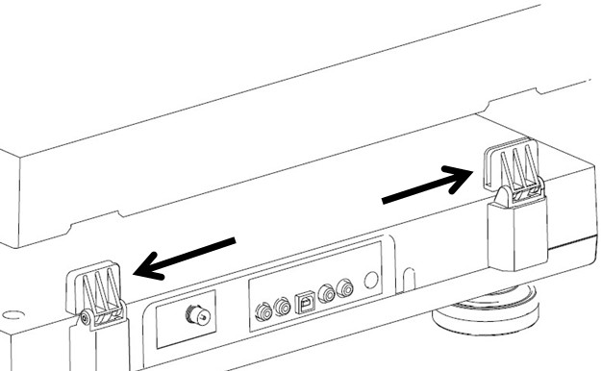

- SET THE TURNTABLE PLATTER ONTO THE CENTER SPINDLE.
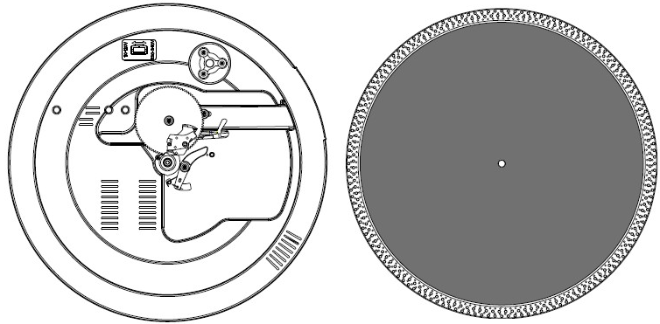
- ATTACH THE DRIVE BELT: POSITION THE BELT ON THE MOTOR PULLY, THE DRIVE BELT IS TIGHTENED UNDER THE TURNTABLE PLATTER.
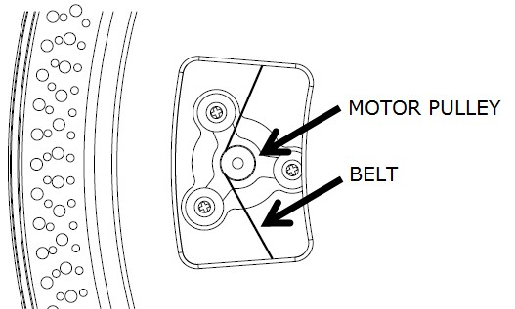
- PLACE THE SLIP MAT ON THE TURNTABLE PLATTER.
- INSERT THE HEADSHLL INTO THE FRONT END OF THE TONEARM, THEN SCREW THE LOCK NUT WITH THE HEADSHELL FIRMLY HELD HORIZONTALLY.
- 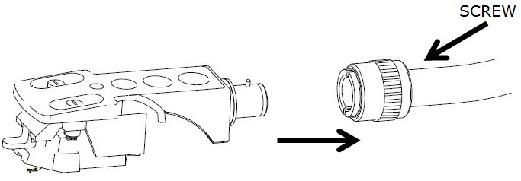
- SLIDE COUNTERWEIGHT ONTO THE TONEARM. TWIST IT LIGHTLY AND IT WILL SCREW INWARDS ONTO THE REAR END OF THE TONEARM.
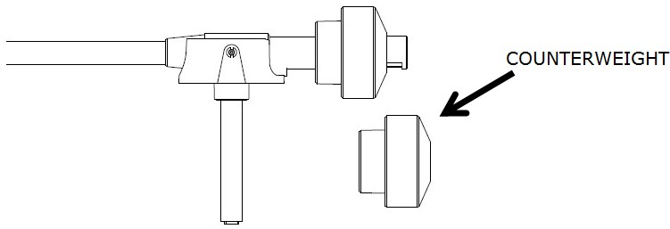

- FOR THE DEFAULT AUDIO-TECHNICA AT-3600L CARTRIDGE, TURN THE CUONTERWEIGHT INWARD TILL IT REACH THE HORIZONTAL LINE AS BELOW:
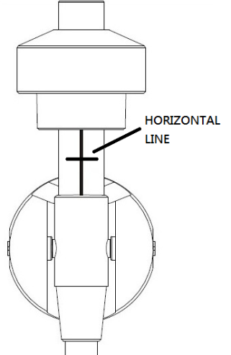

- FOR OTHER CARTRIDGE, USER CAN ADJUST THE TRACKING FORCE BY TURNING COUNTERWEIGHT INWARDS OR BACKWARDS. TURN THE CUONTERWEIGHT INWARD TILL IT REACH THE HORIZONTAL LINE. HOLD THE COUNTER WEIGHT WITH ONE HAND, TURN SCALE RING TO “0” AGAINST THE INDEX LINE ON THE SHAFT WITH ANOTHER HAND, BE SURE NOT TO TURN TOGETHER WITH THE COUNTERWEIGHT
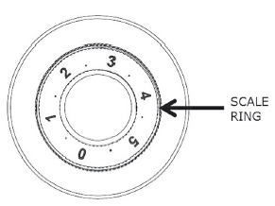
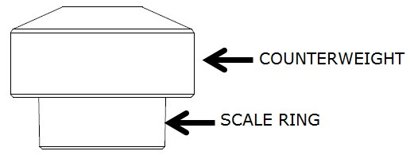
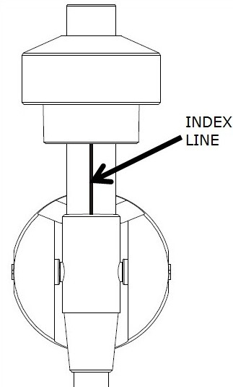

- THE NUMBER ON THE SCALE RING CORRESPOND TO AROUND 0.4G OF TRACKING FORCE. TURNING THE COUNTERWEIGHT INWARD CAN DECREASE THE FORCE, WHILE TURNING THE COUNTERWEIGHT BACKWARD CAN INCREASE THE FORCE.

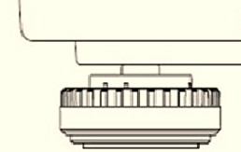
- TURNTABLE FOOT CAN BE TURNED CLOCK-WISE OR COUNTER CLOCK-WISE TO MAKE THE TURNTABLE BALANCED.

LEVEL BALANCE ADJUSTMENT
- SET THE ANTI-SKATE KNOB TO “0”.
- HOLD THE HEADSHELL’S FINGER-LIFT WITH ONE HAND AND ACHIEVE “LEVEL BALANCE” BY TURNING THE COUNTERWEIGHT EITHER CLOCKWISE OR COUNTER CLOCK WISE. “LEVEL BALANCE” MEANS THE TONEARM IS PARALLEL TO THE RECORD ON THE PLATTER, AND THAT THE TONEARM PIPE SHOULD NOT TILT TOWARDS THE COUNTERWEIGHT SIDE OF THE HEADSHELL SIDE

TONEARM PROPERLY BALANCED:
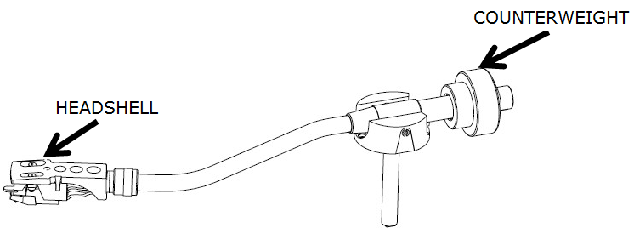

COUNTERWEIGHT END IS TOO HEAVY, TURN THE COUNTERWEIGHT COUNTER-CLOCK WISE TO ADJUST:
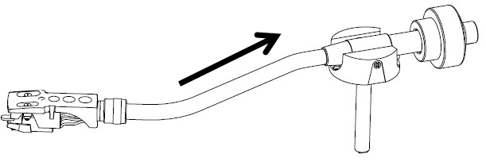

HEADSHELL END IS TOO HEAVY, TURN THE COUNTERWEIGHT CLOCK-WISE TO ADJUST:
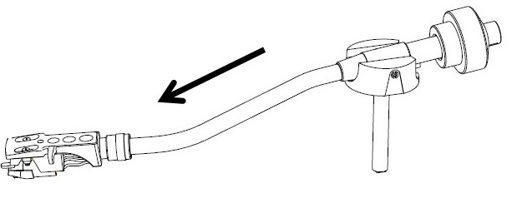
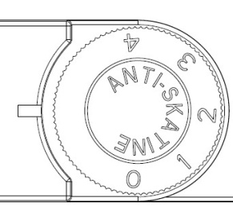
ANTI-SKATING ADJUSTMENT
TO ADJUST THE ANTI SKATING MECHANISM, TURN THE ANTI-SKATE KNOB TILL
THE INDEX LINE AGAINST “0”. TURN THE ANTI-SKATE KNOB TO ADJUST
TRACKING FORCE IF NECESSARY.

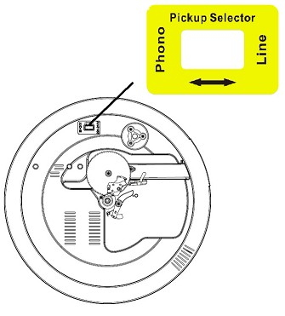
PICKUP SELECTOR
- PICKUP SELECTOR IS LOCATED ON THE TURNTABLE DECK.
- SELECT “PHONO” FOR BUILT-IN PRE-AMPLIFIIER, OR SELECT “LINE” FOR CONNECTION WITH SUITABLE EXTERNAL PRE-AMPLIFIER VIA RCA JACK.
- IF CHANGE TO OTHER NEEDLE OR CARTRIDGE, PUT A SCREW DRIVER INTO PICKUP SELECTOR TO SELECT “LINE”. IN THIS CASE, CONNECT THE PRODUCT WITH SUITABLE EXTERNAL AMPLIFIER (DEPENDS ON THE SPECIFICATION OF THE OTHE NEEDLE OR CARTRIDGE) VIA RCA JACK.

- PRESS FUNCTION BUTTON TO SELECT “PHON” ON DISPLAY.
- REMOVE THE STYLUS PROTECTOR.
- BE SURE THAT THE TONE ARM IS BEING DETACHED FROM THE TONE ARM REST PART BEFORE OPERATING AND RE-SECURED AGAIN AFTERWARDS.
- PUSH THE LIFT LEVER UPWARD TO RAISE THE TONE ARM FROM THE ARM PARK, AND THEN SLOWLY MOVE IT TO THE RECORD SIDE. THE PLATTER WILL START TO ROTATE.
- PUT DOWN THE LIFT LEVER TO DROP THE TONE ARM AND TOUCH THE RECORD GENTLY. PHONO PLAYING STARTS NOW.
- PUSH THE LIFT LEVER UPWARD TO RAISE THE TONE ARM FROM THE ARM PARK, NOW PLATTER WILL STILL BE ROTATING BUT PHONO PLAYING WILL STOP. TO CONTINUE THE PLAYING, THE USER NEEDS TO PUT DOWN THE LIFT LEVER.
- PRESS 33RPM SPEED SELECT OR 45RPM SPEED SELECT BUTTON DEPENDING ON THE RECORD TO BE PLAYED, BUTTON INDICATOR WILL LIGHT UP.
- PRESS START / STOP BUTTON, TURNTABLE WILL STOP ROTATING GENTLY. PRESS START / STOP BUTTON, TURNTABLE WILL ROTATE AGAIN.
- STROB DOTS ON THE TURNTABLE PLATTER FOR SPEED CHECKING. UPPER TWO ROWS FOR 50HZ, LOWER TWO ROWS FOR 60HZ. BIGGER DOTS FOR 45RPM, SMALLER DOTS FOR 33RPM. SUITABLE DOTS WILL KEEP STABLIZED IF THE SPEED IF CORRECT. ADJUST SPEED BY PITCH CONTROL SLIDER (+/-10%).
- PRESS TARGET LIGHT SWTICH, TARGET LIGHT WILL LIGHT UP; PRESS TARGET LIGHT SWTICH AGAIN, TARGET LIGHT WILL BE OFF.
- USE THE 45 RPM ADAPTOR IF REQUIRED.
- ADJUST THE VOLUME TO THE DESIRED LEVEL.
- AT THE END OF RECORD, THE PLATTER WILL AUTOMATICALLY STOP ROTATING, TONE ARM WILL AUTOMATICALLY RETURN TO THE TONE ARM REST PART. TRIGGER THE EJECT SWITCH DURING RECORD PLAYING, TURNTABLE WILL STOP GENTLY AND TONE ARM WILL UTOMATICALLY RETURN TO THE TONE ARM REST PART.
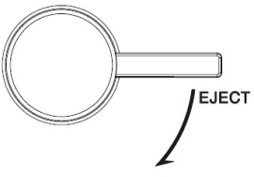

PHONO ENCODING
1. PRESS FUNCTION BUTTON TO SELECT “PHON” ON DISPLAY AND THEN INSERT MEMORY DEVICE (USB DRIVE, SD OR MMC CARD).
2.PRESS THE REC BUTTON, IT WILL TAKE 3-5 SECONDS TO READ MEMORY DEVICE. THEN USB OR SD ICON WILL BE FLASHING.
3.PRESS SKIP UP BUTTON OR SKIP DOWN BUTTON TO SELECT DESIRED MODE (USB OR SD) FOR ENCODING. THEN PRESS THE REC BUTTON AGAIN TO CONFIRM. AND THE SYSTEM IS STARTING THE ENCODING MODE AFTER FEW SECONDSS.
4. IF ONLY USB DRIVE OR SD/MMC CARD IS INSERTED, STEP 3 CAN BE SKIPPED.
5.THE USB OR SD ICON WILL BE FLASHING ON THE DISPLAY DURNIG ENCODING.
5.TO FINISH ENCODING, PRESS STOP BUTTON AND DISPLAY WILL SHOW “END” AND RETURN TO PHONO MODE.

REMARK:-
- THE RECORDING SPEED IS 1:1 AND ACCORDING TO THE ACTUAL PLYING TIME OF THE PHONO
- THE RECORDING FORMAT IS PRESET AT – MP3 BIT RATE : 128 KBPS

AUX IN JACK & ENCODING
PRESS FUNCTION BUTTON TO SELECT “AUX” ON DISPLAY, THEN CONNECT THE EXTERNAL AUDIO DEVICE (SUCH AS CD PLAYER) THROUGH THE AUX IN JACK. AUDIO SIGNAL FROM THE EXTERNAL AUDIO DEVICE CAN BE PLAYED THROUGH THE SYSTEM.

AUX IN ENCODING
1. PRESS FUNCTION BUTTON TO SELECT “AUX” ON DISPLAY, THEN INSERT MEMORY DEVICE (USB DRIVE, SD OR MMC CARD)
2.PRESS THE REC BUTTON, IT WILL TAKE 3-5 SECONDSS TO READ MEMORY DEVICE. THEN USB OR SD ICON WILL BE FLASHING.
3.PRESS SKIP UP BUTTON OR SKIP DOWN BUTTON TO SELECT DESIRED MODE (USB OR SD) FOR ENCODING. THEN PRESS THE REC BUTTON AGAIN TO CONFIRM. AND THE SYSTEM IS STARTING THE ENCODING MODE AFTER FEW SECONDS.
4.IF ONLY USB DRIVE OR SD/MMC CARD IS INSERTED, STEP 3 CAN BE SKIPPED.
5.THE USB OR SD ICON WILL BE FLASHING ON THE DISPLAY DURNIG ENCODING.
6.TO FINISH ENCODING, PRESS STOP BUTTON AND DISPLAY WILL SHOW “END” AND RETURN TO “AUX” MODE.

REMARK:-
- THE RECORDING SPEED IS 1:1 AND ACCORDING TO THE ACTUAL PLYING TIME OF THE EXTERNAL AUDIO DEVICE.
- THE RECORDING FORMAT IS PRESET AT – MP3 BIT RATE : 128 KBPS

PLAYBACK OF MP3/WMA SONG VIA USB STORAGE MEDIA OR MEMORY CARD

CONNECTING
THE SYSTEM IS ABLE TO DECODE AND PLAYBACK ALL MP3 / WMA FILE WHICH STORED IN THE MEMORY MEDIA WITH USB CONNECTING PORT OR SD/MMC MEMORY CARD.

- PLUG-IN THE USB PLUG WITH THE FACE UP & MAKE SURE IT GOING INTO COMPLETELY OR INSERT THE MEMORY CARD IN THE DIRECTION OF THE ARROW AS SHOWN IN THE LABEL ON THE UNDERSIDE OF THE MEMORY CARD SLOT COVER. INSERT STRAIGHT WITHOUT BENDING.
- CONNECTING THE USB UPSIDE DOWN OR BACKWARDS COULD DAMAGE THE AUDIO SYSTEM OR THE STORAGE MEDIA (USB THUMB DRIVE / SD/MMC CARD). CHECK TO BE SURE THE DIRECTION IS CORRECT BEFORE CONNECTION.
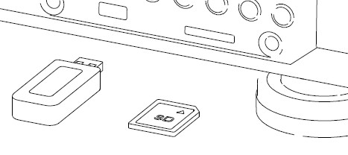

- PRESS FUNCTION BUTTON TO SELECT “USB” OR “CARD” ON DISPLAY, THEN INSERT MEMORY DEVICE (USB DRIVE, SD OR MMC CARD).
- THE SYSTEM WILL START READING THE STORAGE MEDIA AUTOMATICALLY AFTER FUNCTION SELECTION, AND DISPLAY WILL SHOW THE TOTAL NUMBER OF MP3/WMA FILES (EG. 016).
- THEN THE SYSTEM WILL START AUDIO PLAYBACK FROM DESRIED DEVICE (USB OR SD/MMC) AUTOMATICALLY.

- PLAY / PAUSE BUTTON
- PRESS THE PLAY/PAUSE BUTTON ONCE TO HALT PLAYING, PRESS IT AGAIN TO CONTINUE.

- STOP BUTTON
- PRESS STOP BUTTON TO END UP AUDIO PLAYBACK, THEN DISPLAY WILL SHOW THE TOTAL NUMBER OF MP3/WMA FILES. AND THEN USER CAN PRESS SKIP UP” OR SKIP DOWN BUTTON TO SELECT FILE FORWARD OR BACKWARD.

- SKIP UP / SKIP DOWN BUTTON
- DURING MP3/WMA PLAYBACK, PRESS SKIP UP BUTTON ONCE TO PLAY THE NEXT FILE. PRESS AND HOLD SKIP UP BUTTON CONTINUOUSLY TO SPEED UP SELECTING FORWARD.
- DURING MP3/WMA PLAYBACK, PRESS SKIP DOWN BUTTON ONCE TO PLAY THE PREVIOUS FILE. PRESS AND HOLD SKIP DOWN BUTTON CONTINUOUSLY TO SPEED UP SELECTING BACKWARD.

- FOLDER SEARCHING
PRESS ALBUM DOWN OR ALBUM UP TO SEARCH FOLDER BACKWARD OR FORWARD.

- REPEAT FUNCTION
DURING AUDIO PLAYBACK, PRESS MODE BUTTON ONCE, SINGLE TRACK WILL BE PLAYED REPEATEDLY. PRESS MODE BUTTON AGAIN, IT WILL REPEATEDLY PLAY ALL TRACKS IN THE WHOLE USB DRIVE, SD OR MMC CARD.

REMARK
- IF CONNECT THE SYSTEM TO MP3 PLAYER VIA THE USB SOCKET, DUE TO VARIANCES IN MP3 ENCODING FORMAT, SOME MP3 PLAYER MAY NOT BE ABLE TO PLAY VIA THE USB SOCKET. THIS IS NOT A MALFUNCTION OF THE SYSTEM.
- THERE ARE NUMEROUS USB AND SD DEVICE PRODUCERS ARE. SOLUTION AND FORMAT ARE VARIABLE BETEEN EACH OTHER. THEREFORE, WE DO NOT GARANTTEE THIS UNIT CAN SUPPORT ALL USB AND SD DEVICE FROM EVERY BRAND.
- SD CARD CAN BE SUPPORED UP TO 8GB

TRACKS PROGRAMMING
UP TO 60 TRACKS CAN BE PROGRAMMED FOR MP3/WMA FILE AND PLAY IN ANY ORDER. BEFORE USE, BE SURE THE SYSTEM IS AT STOP MODE BEFORE PROGRAMMING:

- SET AT “USB” OR “CARD” FUNCTION, THEN PRESS STOP BUTTON.
- PRESS MODE BUTTON, “MEM” WILL BE FLASHING ON LCD DISPLAY. MOREOVER, IT WILL INDICATE PROGRAM NO. AND DIGITS FOR TRACK NO. TO BE PROGRAMMED.
- SELECT A DESIRED TRACK BY PRESSING SKIP UP OR SKIP DOWN BUTTON. IF FOLDER SELECTION IS REQUIRED, PRESSING ALBUM DOWN OR ALBUM UP TO SEARCH FOLDER BACKWARD OR FORWARD.
- PRESS MODE BUTTON TO CONFIRM AND STORE THE TRACK INTO MEMORY.
- REPEAT STEPS 3 AND 4 TO ENTER ADDITIONAL TRACKS INTO THE MEMORY IF NECESSARY.
- WHEN ALL THE DESIRED TRACKS HAVE BEEN PROGRAMMED, PRESS PLAY/PAUSE BUTTON TO PLAY THE TRACKS IN ASSIGNED ORDER.
- PRESS STOP BUTTON TO STOP PLAYING OF PROGRAMMED TRACKES, PRESS STOP BUTTON AGAIN TO CANCEL PROGRAMMING.

COPYING OF MP3/WMA FILE
- THE SYSTEM ALLOWS YOU TO COPY THE FILE FROM USB TO SD OR SD TO USB BY 1 FILE, 1 FOLDER OR ALL FILES.
- MP3/WMA FILE WILL BE COPIED IN HIGH SPEED FROM USB TO SD OR FROM SD TO USB DURING STOP MODE.

I) COPY 1 TRACK
  - INSERT THE USB STORAGE MEDIA OR SD/MMC CARD, SET IN “USB” OR “CARD” MODE.
  - PRESS REC BUTTON DURING THE PLAYBACK OF THE COPYING TRACK, THEN “ONE” WILL BE FLASHING ON THE DISPLAY. PRESS REC BUTTON AGAIN TO CONFIRM.
  - THE USB OR SD ICON WILL BE FLASHING ON THE DISPLAY. COPYING IS PERFORMING NOW.
  - AFTER COMPLETING OF COPY, UNIT WILL STOP PLAYBACK AUTOMATICALLY.
  - DISPLAY WILL SHOW “END” AND BACK TO USB OR SD MODE.

II) COPY 1 FOLDER
1.INSERT THE USB STORAGE MEDIA OR SD/MMC CARD, SET IN “USB” OR “CARD” MODE.
2. PRESS ALBUM DOWN OR ALBUM UP TO SEARCH DESIRED FOLDER FOR COPYING.
3. PRESS REC BUTTON, THEN “ONE” WILL BE FLASHING ON THE DISPLAY. PRESS SKIP UP / SKIP DOWN BUTTON TO SELECT “DIR” ON THE DISPLAY. PRESS REC BUTTON AGAIN TO CONFIRM.
4. USB OR SD ICON WILL BE FLASHING ON THE DISPLAY. COPYING IS PERFORMING NOW.
5. WHEN THE USB OR SD ICON STOPS FLASHING, IT MEANS THAT THE FOLDER COPYING IS COMPLETED.

III) COPY ALL TRACK
1.INSERT THE USB STORAGE MEDIA OR SD/MMC CARD, SET IN “USB” OR “CARD” MODE.
2. PRESS REC BUTTON, THEN “ONE” WILL BE FLASHING ON THE DISPLAY. PRESS SKIP UP / SKIP DOWN BUTTON TO SELECT “ALL” ON THE DISPLAY. PRESS REC BUTTON AGAIN TO CONFIRM.
4. USB OR SD ICON WILL BE FLASHING ON THE DISPLAY. COPYING IS PERFORMING NOW.
5. WHEN THE USB OR SD ICON WILL STOP FLASHING, IT MEANS THAT ALL TRACK COPYING IS COMPLETED.

REMARK:
- IF PRESS THE REC BUTTON DURING PLAYBACK OF USB OR SD MODE, THE FILE WILL COPY FROM USB TO SD OR SD TO USB.

FILE DELETE FROM USB / SD CARD
THE SYSTEM IS ABLE TO ERASE THE FILE STORED INSIDE THE USB DRIVE OR SD CARD BY FOLLOWING:-

I) DELETE 1 TRACK
1. PRESS AND HOLD DEL BUTTON FOR 3-5 SECONDS DURING THE PLAYBACK OF THE DESIRED TRACK, THEN “ONE” WILL BE FLASHING ON THE DISPLAY. PRESS DEL BUTTON AGAIN TO CONFIRM.
2. “DEL” WILL BE SHOWN ON THE DISPLAY.
3. “DEL” WILL DISAPPEAR ON THE DISPLAY, IT MEANS THE TRACK IS DELETED.

II) DELETE 1 FOLDER
- INSERT THE USB STORAGE MEDIA OR SD/MMC CARD, SET IN “USB” OR “CARD” MODE & SET AT STOP MODE AFTER UNIT READING.
- PRESS ALBUM DOWN OR ALBUM UP TO SEARCH DESIRED FOLDER FOR DELETING.
- PRESS AND HOLD DEL BUTTON FOR 3-5 SECONDS, “DEL” WILL SHOW ON THE DISPLAY. PRESS SKIP UP / SKIP DOWN BUTTON TO SELECT “DIR” ON THE DISPLAY. PRESS DEL BUTTON AGAIN TO CONFIRM.
- “DEL” WILL BE SHOWN ON THE DISPLAY. AFTER “DEL” DISAPPEARS IT MEANS THE DESIRED FOLDER IS DELETED.

II) DELETE ALL TRACK
- INSERT THE USB STORAGE MEDIA OR SD/MMC CARD, SET IN “USB” OR “CARD” MODE & SET AT STOP MODE AFTER UNIT READING.
- PRESS AND HOLD DEL BUTTON FOR 3-5 SECONDS, THEN “ONE” WLL BE FLASHING ON THE DISPLAY. PRESS SKIP UP / SKIP DOWN BUTTON TO SELECT “ALL” ON THE DISPLAY. PRESS DEL BUTTON AGAIN TO CONFIRM.
- USB OR SD ICON WILL BE FLASHING ON THE DISPLAY. DELETING IS PERFORMING NOW.
- WHEN THE USB OR SD ICON STOPS FLASHING, IT MEANS THAT ALL TRACK COPYING IS COMPLETED.

REMARK : ALL THE FILES INSIDE THE USB STORAGE MEDIA OR SD CARD WILL BE DELETED COMPLETELY AFTER CONFIRMING TO “DEL” BUTTON.

REMOVING OF USB / MEMORY CARD
TO REMOVE THE USB / MEMORY CARD, TURN OFF THE POWER OR SWITCH THE FUNCTION MODE TO EITHER CD, AUX OR TUNER FIRST. UN-PLUG IT BY PULLING OUT THE USB/CD SOCKET DIRECTLY.

COMPACT DISC (CD) PLAYBACK & ENCODING
1. PRESS FUNCTON BUTTON TO “CD” MODE.
2. PRESS CD OPNE/CLOSE BUTTON, CD DOOR WILL BE OPENED, PUT THE CD IN THE TRAY AND PRESS CD OPNE/CLOSE BUTTON AGAIN, CD DOOR WILL BE CLOSED.
3.THE SYSTEM WILL START READING THE CD:

- PLAY / PAUSE BUTTON
- PRESS THE PLAY/PAUSE BUTTON ONCE TO HALT PLAYING, PRESS IT AGAIN TO CONTINUE.

- STOP BUTTON
- PRESS THE STOP BUTTON TO END UP AUDIO PLAYBACK, THEN DISPLAY WILL SHOW THE TOTAL NUMBER OF TRACKS. AND THEN USER CAN PRESS SKIP UP OR SKIP DOWN BUTTON TO SELECT TRACKS.

- SKIP UP / SKIP DOWN BUTTON
- DURING CD PLAYBACK, PRESS SKIP UP BUTTON ONCE TO PLAY THE NEXT TRACK. PRESS AND HOLD SKIP UP BUTTON CONTINUOUSLY TO SPEED UP SELECTING FORWARD.
- DURING CD PLAYBACK, PRESS SKIP DOWN” BUTTON ONCE TO PLAY THE PREVIOUS TRACK. PRESS AND HOLD SKIP DOWN” BUTTON CONTINUOUSLY TO SPEED UP SELECTING BACKWARD.

- FOLDER SEARCHING
PRESS ALBUM DOWN OR ALBUM UP TO SEARCH FOLDER BACKWARD OR FORWARD.

- REPEAT FUNCTION
DURING AUDIO PLAYBACK, PRESS MODE BUTTON ONCE, SINGLE TRACK WILL BE PLAYED REPEATEDLY. PRESS MODE BUTTON (5) AGAIN, IT WILL REPEATEDLY PLAY ALL TRACKS IN THE WHOLE CD.

TRACKS PROGRAMMING
UP TO 60 MP3 TRACKS & 30 CD AUDIO FORMAT TRACK CAN BE PROGRAMMED AND PLAYED IN ANY ORDER. BEFORE USE, BE SURE THE SYSTEM IS AT STOP MODE BEFORE PROGRAMMING:

1. PRESS FUNCTON BUTTON TO “CD” AND AT STOP MODE
2.PRESS THE MODE BUTTON, “MEM” WILL BE FLASHING ON LCD DISPLAY. MOREOVER, IT WILL INDICATE PROGRAM NO. AND DIGITS FOR TRACK NO. TO BE PROGRAMMED.
3.SELECT A DESIRED TRACK BY PRESSING SKIP UP OR SKIP DOWN BUTTON. FOR MP3/WMA DISC, PRESSING ALBUM DOWN OR ALBUM UP TO SEARCH FOLDER BACKWARD OR FORWARD.
4.PRESS THE MODE BUTTON TO STORE THE TRACK INTO MEMORY.
5.REPEAT STEPS 3 AND 4 TO ENTER ADDITIONAL TRACKS INTO THE MEMORY IF NECESSARY.
6.WHEN ALL THE DESIRED TRACKS HAVE BEEN PROGRAMMED, PRESS PLAY/PAUSE BUTTON TO PLAY THE TRACKS IN ASSIGNED ORDER.
7. PRESS STOP BUTTON TO STOP PLAYING OF PROGRAMMED TRACKES, PRESS STOP BUTTON AGAIN TO CANCEL PROGRAMMING.

CD RECORDING TO USB/SD
- THE SYSTEM ALLOWS YOU TO COPY THE TRACK FROM CD TO USB OR SD BY 1 TRACK, 1 FOLDER OR ALL FILES.
- MP3/WMA FILE WILL BE COPIED IN HIGH SPEED FROM CD TO USB/SD DURING STOP MODE.

I) COPY 1 TRACK
1.INSERT THE USB STORAGE MEDIA OR SD/MMC CARD, PRESS FUNCTON BUTTON TO “CD” MODE.
2.PRESS REC BUTTON DURING THE PLAYBACK OF THE COPYING TRACK FROM CD, THEN “ONE” WILL BE FLASHING ON THE DISPLAY. PRESS REC BUTTON AGAIN TO CONFIRM.
3.THE USB OR SD ICON WILL BE FLASHING ON THE DISPLAY. COPYING IS PERFORMING NOW.
4.AFTER COMPLETING OF COPY, UNIT WILL STOP PLAYBACK AUTOMATICALLY.
5.DISPLAY WILL SHOW “END” AND BACK TO CD MODE.

II) COPY 1 FOLDER (FOR MP3/WMA DISC ONLY)
1.INSERT THE USB STORAGE MEDIA OR SD/MMC CARD, SET IN CD & STOP MODE AFTER UNIT READING.
2. PRESS ALBUM DOWN OR ALBUM UP TO SEARCH FOLDER FOR COPYING.
3. PRESS REC BUTTON, THEN “ONE” WILL BE FLASHING ON THE DISPLAY. PRESS SKIP UP / SKIP DOWN BUTTON TO SELECT “DIR” ON THE DISPLAY. PRESS REC BUTTON AGAIN TO CONFIRM.
4. USB OR SD ICON WILL BE FLASHING ON THE DISPLAY. COPYING IS PERFORMING NOW.
5. WHEN THE USB OR SD ICON STOPS FLASHING, IT MEANS THAT THE FOLDER COPYING IS COMPLETED.

III) COPY ALL TRACK
1.INSERT THE USB STORAGE MEDIA OR SD/MMC CARD, PRESS FUNCTON BUTTON TO “CD” MODE.
2. PRESS REC BUTTON, THEN “ONE” WLL BE FLASHING ON THE DISPLAY. PRESS SKIP UP / SKIP DOWN BUTTON TO SELECT “ALL” ON THE DISPLAY. PRESS REC BUTTON AGAIN TO CONFIRM.
4. USB OR SD ICON WILL BE FLASHING ON THE DISPLAY. COPYING IS PERFORMING NOW.
5. WHEN THE USB OR SD ICON STOPS FLASHING, IT MEANS THAT ALL TRACK COPYING IS COMPLETED.

SPLIT TRACK FUNCTION FOR USB/SD RECORDING FOR TURNTABLE
1) MANUAL SPLIT OPERATION PROCEDURE: DURING USB/SD RECORDING, THE USB/SD ICON WILL FLASH ON THE DISPLAY. IF A NEW TRACK IS REQUIRED, PRESS MODE BUTTON ON THE UNIT OR REMOTE CONTROL, DISPLAY WILL SHOW “TS”, THEN THE UNIT WILL STOP RECORDING MOMENTARILY AND RESUME AGAIN. A NEW FILE WILL HAVE BEEN CREATED ON THE USB/SD DEVICE REPRESNTING A NEW TRACK.

2) AUTO SPLIT OPERATION PROCEDURE:
- BEFORE USB/SD RECORDING, PRESS FUNCT BUTTON TO SELECT AUDIO SOURCE, THEN PRESS MODE BUTTON ON THE UNIT OR REMOTE CONTROL, DISPLAY WILL SHOW “T-ON”, WHICH MEANS THE AUTO SPLIT FUNCTION HAS ACTIVATED. THEN START USB/SD RECORDING, THE UNIT CAN AUTOMATICALLY DETECT THE SILENT PART BETWEEN EACH TRACK, AND CREATE A NEW FILE TO MOVE ON TO START RECORDING THE NEXT TRACK.
- IF NOT REQUIRED: PRESS MODE BUTTON ON THE UNIT OR REMOTE CONTROL BEFORE USB/SD RECORDING, DISPLAY WILL SHOW “T-OF”, WHICH MEANS AUTO SPLIT HAS BEEN DEACTIVATED.
- PLEASE NOTE FOR AUTO SPLIT: SEVERAL SECONDS OF THE BEGINNING OF THE NEXT TRACK MAY NOT BE RECORDED, AS THE UNIT MAY TAKE A FEW SECONDS TO CREATE A NEW FILE ON THE USB/SD; AND IT CAN ADDITIONALLY BE THE CASE THAT SOME MUSIC PRODUCERS INTENTIONALLY ADD SILENT SECTIONS WITHIN ONE TRACK. AS A RESULT, THIS WILL VERY LIKELY MAKE THE UNIT CONSIDER THIS SILENT PART THE BREAK BETWEEN TRACKS AND CREATE A NEW TRACK ON THE RECORDING.
- NOTE FOR AUTO SPLIT: DURING USB/SD RECORDING FROM TURNTABLE, WHEN THE UNIT HAS DETECTED ANY PARTICULAR SILENT PART, THE TURNTABLE WILL STOP MOMENTARILY. THE TURNTABLE WILL RESUME OPERATION ONCE THE USB/SD DEVICE HAS BEGUN CREATING A NEW FILE TO BE RECORDED.

EARPHONE JACK & LINE OUT SOCKET
- THIS SYSTEM CAN BE CONNECTED WITH HEADPHONE OR EXTERNAL AMPLIFIER / SPEAKER BY 3.5MM EARPHONE JACK.
- THIS SYSTEM CAN BE CONNECTED WITH EXTERNAL DEVICE (EG. ACTIVE AMPLIFIER AND SPEAKER) BY LINE-OUT SOCKET AT REAR CABINET.
- CONNECT EXTERNAL DEVICE (EG. ACTIVE AMPLIFIER AND MIXER) WITH GROUND LEAD IF NECESSARY.

REMOTE CONTROL

BATTERY INSTALLATION
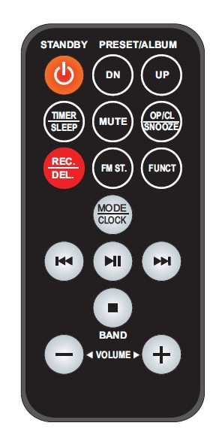
THE INFRA-RED TRANSMITTER REQUIRES 1 PC CR2025 LITHUM BATTERY FOR OPERATION

BUTTON DESCRIPTION

- STANDBY: TRIGGER BETWEEN STANDBY MODE AND OPERATION MODE.
- PRESET/ALBUM DN: PERFORM SAME FUNCTION AS “ALBUM DOWN / PRESET DOWN” BUTTON ON THE UNIT.
- PRESET/ALBUM UP: PERFORM SAME FUNCTION AS “ALBUM UP / PRESET UP” BUTTON ON THE UNIT.
- TIMER / SLEEP: PERFORM SAME FUNCTION AS “SLEEP / TIMER” BUTTON ON THE UNIT.
- MUTE: TO MUTE AUDIO PLAYBACK.
- OP/CL & SNOOZE: OPEN AND CLOSE THE CD DOOR; SNOOZE FUNCTION FOR ALARM.
- REC/DEL: PERFORM SAME FUNCTION AS “REC/DEL” BUTTON ON THE UNIT.
- FM ST.: SELECT BETWEEN FM STEREO AND MONO RADIO
- FUNCT: PERFORM SAME FUNCTION AS “FUNCTION” BUTTON ON THE UNIT.
- MODE/CLOCK: PERFORM SAME FUNCTION AS “MODE/CLOCK” BUTTON ON THE UNIT.
- (PLAY/PAUSE): PERFORM SAME FUNCTION AS “ PLAY/PAUSE” BUTTON ON THE UNIT.
- (STOP)/BAND: PERFORM SAME FUNCTION AS “ (STOP)/BAND” BUTTON ON THE UNIT.
- (SKIP DOWN ): PERFORM SAME FUNCTION AS “ (SKIP DOWN )” BUTTON ON THE UNIT. BESIDES, IT CAN BE USED FOR RADIO FREQUENCY SEARCHING DURING TUNER MODE.
- (SKIP UP ): PERFORM SAME FUNCTION AS “ (SKIP UP)” BUTTON ON THE UNIT. BESIDES, IT CAN BE USED FOR RADIO FREQUENCY SEARCHING DURING TUNER MODE.
- VOLUME +/- : CONTROL VOLUME LEVEL.

